For ASME B16.5 Flanges | 渦卷型墊片規格表(內外輪)  同安成T.A.C
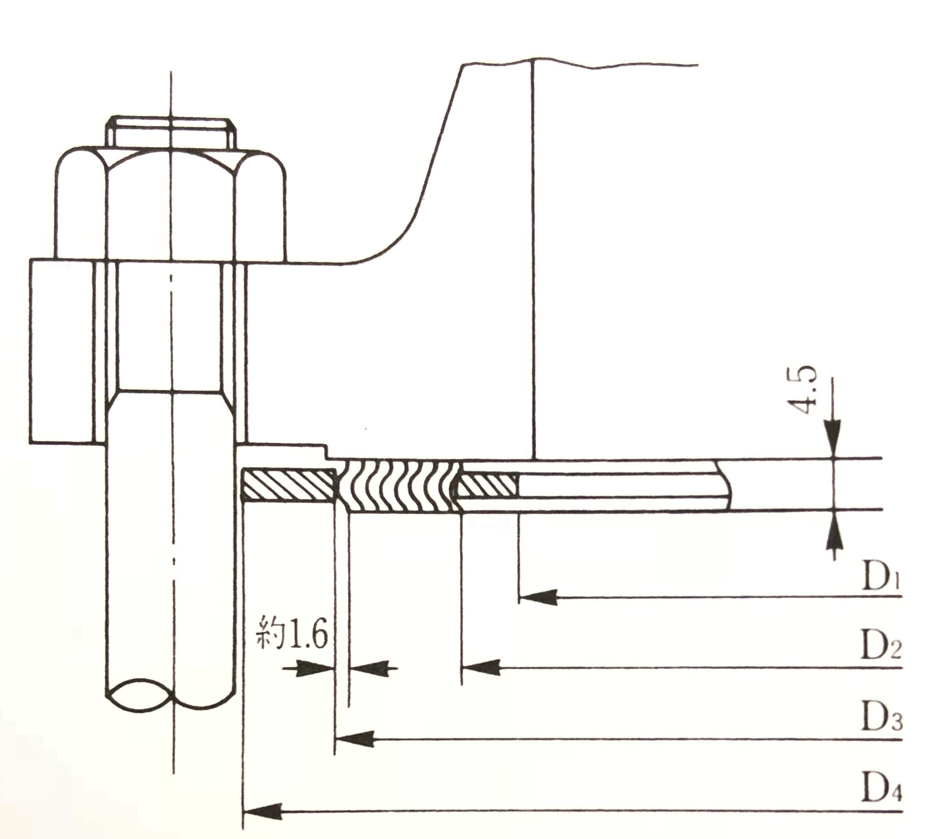
根據: ASME B16.20-2007
適用法蘭: ASME B16.5

法蘭尺寸 | Class 150 |  |  |  | Class 300 |  |  |  | Class 400
法蘭尺寸 | D1 | D2 | D3 | D4 | D1 | D2 | D3 | D4 | D1 | D2 | D3 | D4
1/2”  3/4”  1” | 14.2  20.6  26.9 | 19.1  25.4  31.8 | 31.8  39.6  47.8 | 47.8  57.2  66.8 | 14.2  20.6  26.9 | 19.1  25.4  31.8 | 31.8  39.6  47.8 | 54.1  66.8  73.2 | Class 400無1/2”~3”尺寸，請參照Class 600
1-1/4”  1-1/2”  2” | 38.1  44.5  55.6 | 47.8  54.1  69.9 | 60.5  69.9  85.9 | 76.2  85.9  104.9 | 38.1  44.5  55.6 | 47.8  54.1  69.9 | 60.5  69.9  85.9 | 82.6  95.3  111.3
2-1/2”  3” | 66.5  81.0 | 82.6  101.6 | 98.6  120.7 | 124.0  136.7 | 66.5  81.0 | 82.6  101.6 | 98.6  120.7 | 130.3  149.4
4”  5”  6” | 106.4  131.8  157.2 | 127.0  155.7  182.6 | 149.4  177.8  209.6 | 174.8  196.9  222.3 | 106.4  131.8  157.2 | 127.0  155.7  182.6 | 149.4  177.8  209.6 | 181.1  215.9  251.0 | 102.6  128.3  154.9 | 120.7  147.6  174.8 | 149.4  177.8  209.6 | 177.8  212.9  247.7
8”  10”  12” | 215.9  268.2  317.5 | 233.4  287.3  339.9 | 263.7  317.5  374.7 | 279.4  339.9  409.7 | 215.9  268.2  317.5 | 233.4  287.3  339.9 | 263.7  317.5  374.7 | 308.1  362.0  422.4 | 205.7  255.3  307.3 | 225.6  274.6  327.2 | 263.7  317.5  374.7 | 304.8  358.9  419.1
14”  16”  18” | 349.3  400.1  449.3 | 371.6  422.4  474.7 | 406.4  463.6  527.1 | 450.9  514.4  549.4 | 349.3  400.1  449.3 | 371.6  422.4  474.7 | 406.4  463.6  527.1 | 485.9  539.8  596.9 | 342.9  389.9  438.2 | 362.0  412.8  469.9 | 406.4  463.6  527.1 | 482.6  536.7  593.9
20”  24” | 500.1  603.3 | 525.5  628.7 | 577.9  685.8 | 606.6  717.6 | 500.1  603.3 | 525.5  628.7 | 577.9  685.8 | 654.1  774.7 | 489.0  590.6 | 520.7  628.7 | 577.9  685.8 | 647.7  768.4

法蘭尺寸 | Classs 600 |  |  |  | Class 900 |  |  |  | Class 1500 |  |  |  | Class 2500
法蘭尺寸 | D1 | D2 | D3 | D4 | D1 | D2 | D3 | D4 | D1 | D2 | D3 | D4 | D1 | D2 | D3 | D4
1/2”  3/4”  1” | 14.2  20.6  26.9 | 19.1  25.4  31.8 | 31.8  39.6  47.8 | 54.1  66.8  73.2 | Class 900無1/2”~2-1/2”尺寸，請參照Class 1500 |  |  |  | 14.2  20.6  26.9 | 19.1  25.4  31.8 | 31.8  39.6  47.8 | 63.5  69.9  79.5 | 14.2  20.6  26.9 | 19.1  25.4  31.8 | 31.8  39.6  47.8 | 69.9  76.2  85.9
1-1/4”  1-1/2”  2”  2-1/2” | 38.1  44.5  55.6  66.5 | 47.8  54.1  69.9  82.6 | 60.5  69.9  85.9  98.6 | 82.6  95.3  111.3  130.3 |  |  |  |  | 33.3  41.4  52.3  63.5 | 39.6  47.8  58.7  69.9 | 60.5  69.9  85.9  98.6 | 88.9  98.6  143.0  165.1 | 33.3  41.4  52.3  63.5 | 39.6  47.8  58.7  69.9 | 60.5  69.9  85.9  98.6 | 104.9  117.6  146.1  168.4
3”  4”  5” | 81.0  102.6  128.3 | 101.6  120.7  147.6 | 120.7  149.4  177.8 | 149.4  193.8  241.3 | 78.7  102.6  128.3 | 95.3  120.7  147.6 | 120.7  149.4  177.8 | 168.4  206.5  247.7 | 78.7  97.8  124.5 | 92.2  117.6  143.0 | 120.7  149.4  177.8 | 174.8  209.6  254.0 | 78.7  97.8  124.5 | 92.2  117.6  143.0 | 120.7  149.4  177.8 | 196.9  235.0  279.4
6”  8”  10” | 154.9  205.7  255.3 | 174.8  225.6  274.6 | 209.6  263.7  317.5 | 266.7  320.8  400.1 | 154.9  196.9  246.1 | 174.8  222.3  276.4 | 209.6  257.3  311.2 | 289.1  358.9  435.1 | 147.3  196.9  246.1 | 171.5  215.9  266.7 | 209.6  257.3  311.2 | 282.7  352.6  435.1 | 147.3  196.9  246.1 | 171.5  215.9  270.0 | 209.6  257.3  311.2 | 317.5  387.4  476.3
12”  14”  16” | 307.3  342.9  389.9 | 327.2  362.0  412.8 | 374.7  406.4  463.6 | 457.2  492.3  565.2 | 292.1  320.8  374.7 | 323.9  355.6  412.8 | 368.3  400.1  457.2 | 498.6  520.7  574.8 | 292.1  320.8  368.3 | 323.9  362.0  406.4 | 368.3  400.1  457.2 | 520.7  577.9  641.4 | 292.1  --  -- | 317.5  --  -- | 368.3  --  -- | 549.4  --  --
18”  20”  24” | 438.2  489.0  590.6 | 469.9  520.7  628.7 | 527.1  577.9  685.8 | 612.9  682.8  790.7 | 425.5  482.6  590.6 | 463.6  520.7  628.7 | 520.7  571.5  679.5 | 638.3  698.5  838.2 | 425.5  476.3  577.9 | 463.6  514.4  616.0 | 520.7  571.5  679.5 | 704.9  755.7  901.7 | --  --  -- | --  --  -- | --  --  -- | --  --  --

